**Final Project**



**Table of Contents:**

Page 1: Title and logo

Page 2: Table of Contents

Page 3: Version history, Detailed Game Description, Controls, and Interface Sketch

Page 4: Screen Descriptions (Start State and Gameplay State)

Page 5: Screen Descriptions (Game-End State), Characters/Vehicles, Enemies, Scoring, and Sound Index

Page 6: Art / Multimedia Index (bullet image, grass image, tank mesh, bomb mesh, wrench mesh)

Page 7: All Assets Used

**Version History:**

Version 1 – December 2nd 2015

**Detailed Game Description:**

Level 1 – Get to the end of the training maze

**Controls:**

WASD – Forward, left, back, right.

Space – Jump.

**Interface Sketch:**

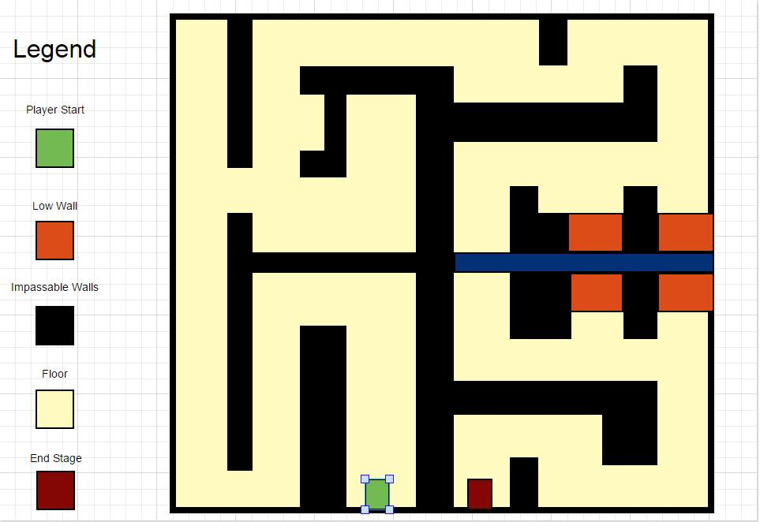

**Screen Descriptions:**

Start State:

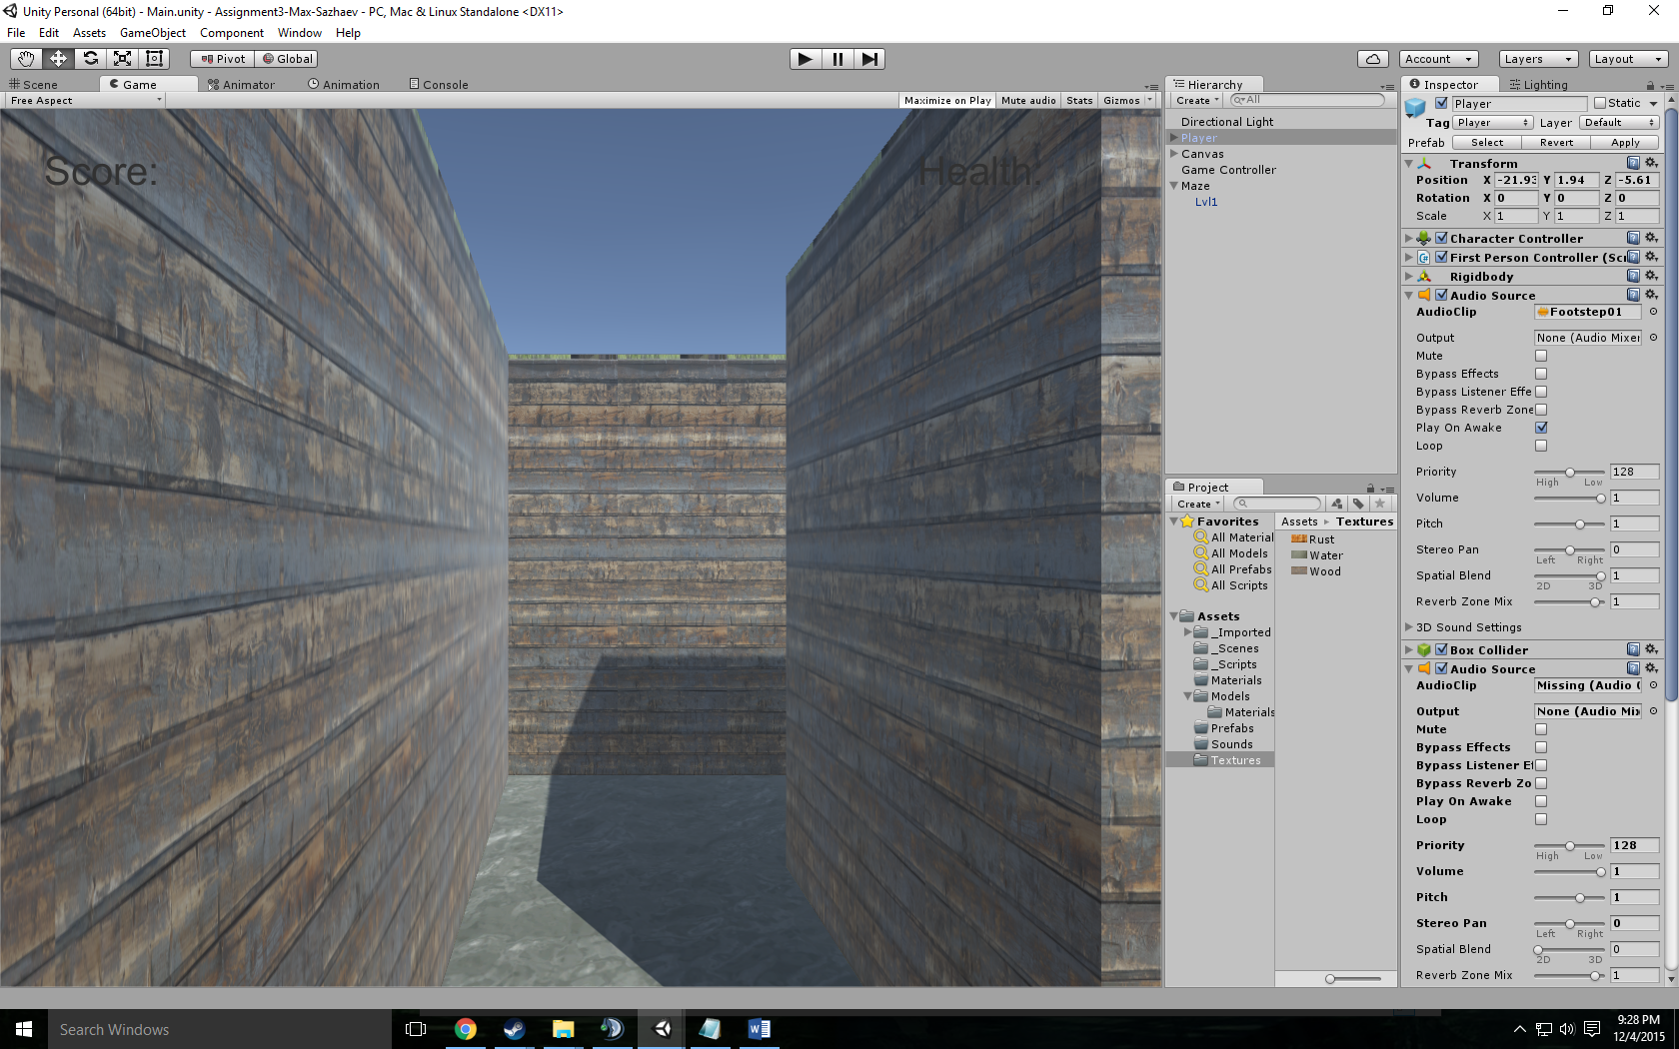

Gameplay State:

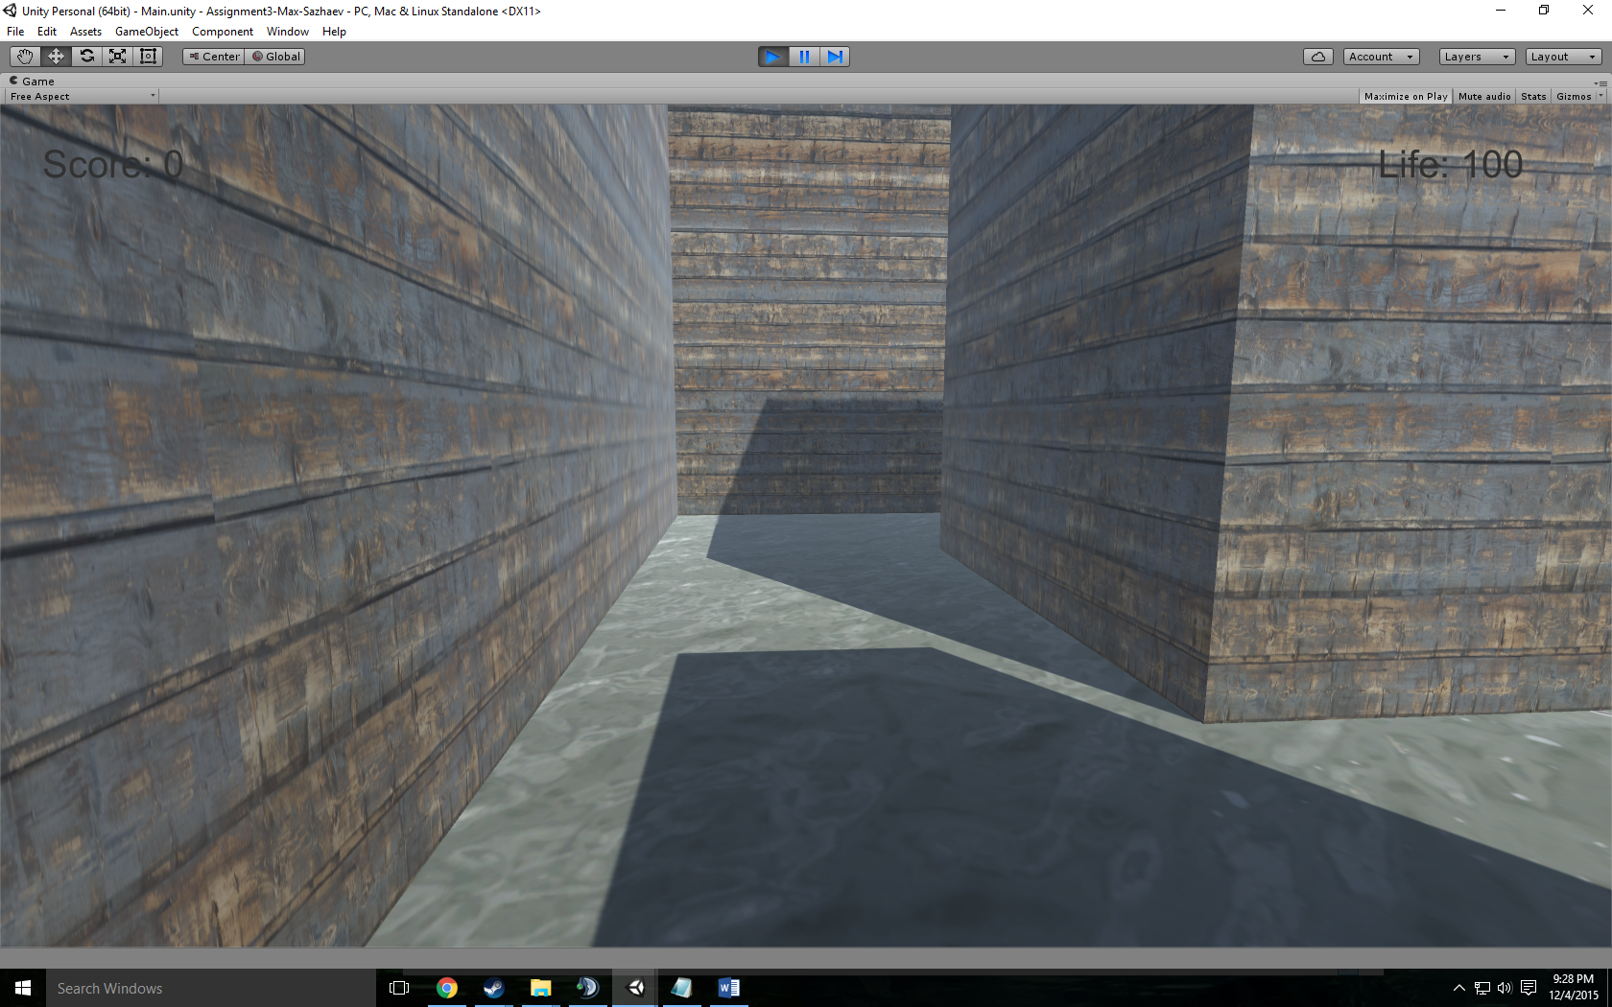

Game-End State:

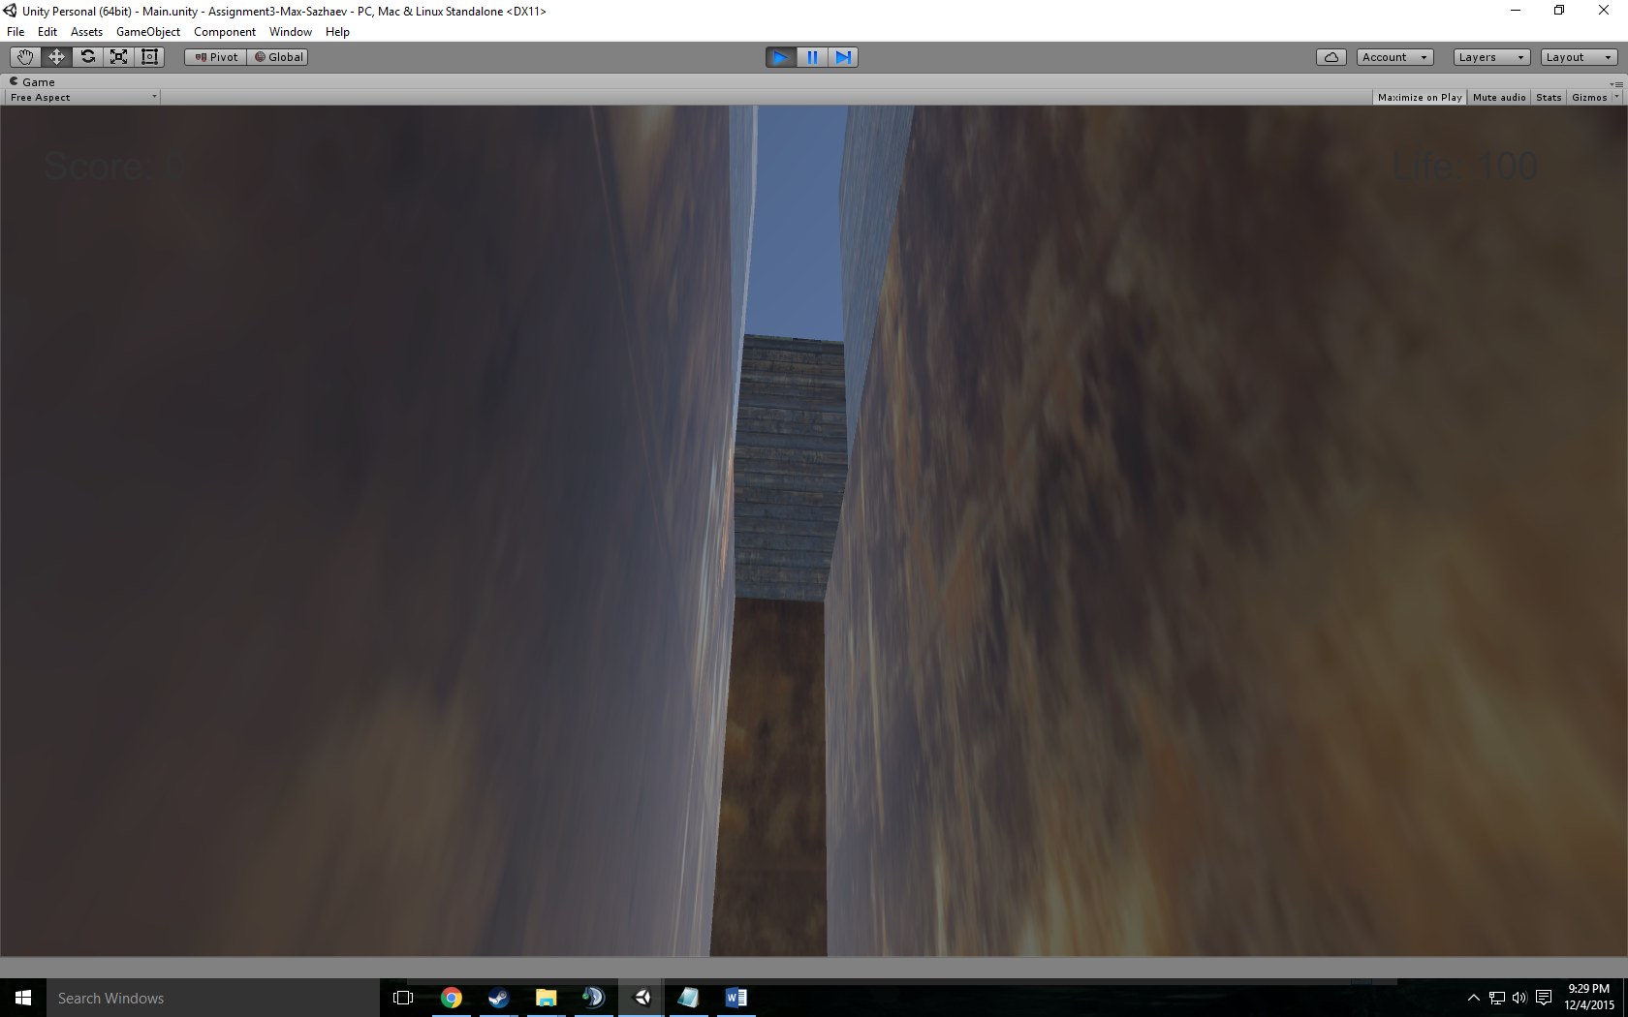

**Characters / Vehicles:**

Player – moves forward, back, left, and right.

**Enemies:**

N.A

**Scoring:**

N.A

**Sound Index:**

Footstep01 – Walking Sound

Jump – jump up sound

Land – Landing sound

**Art / Multimedia Index:**

Rust Texture:

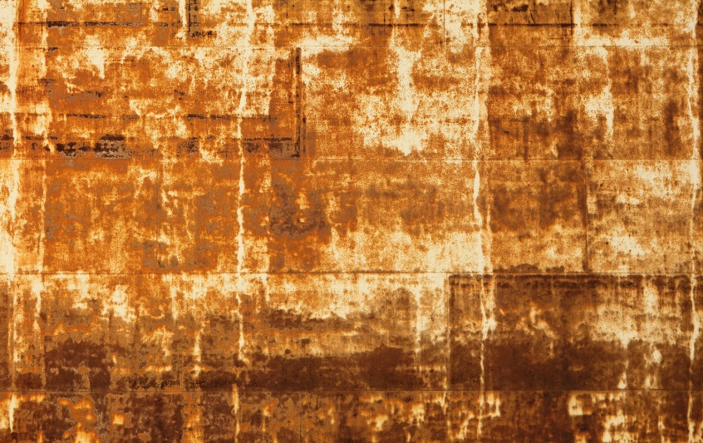

Water Texture:

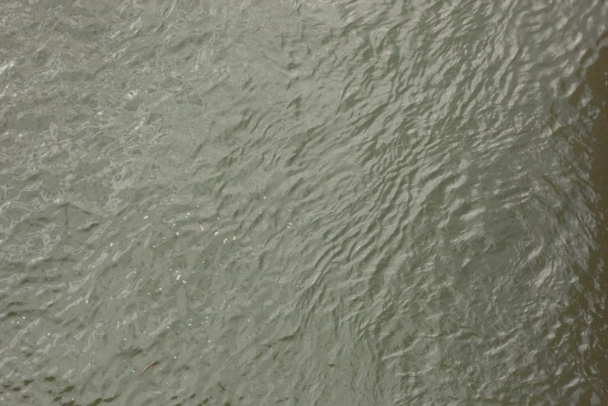

Wood Texture:

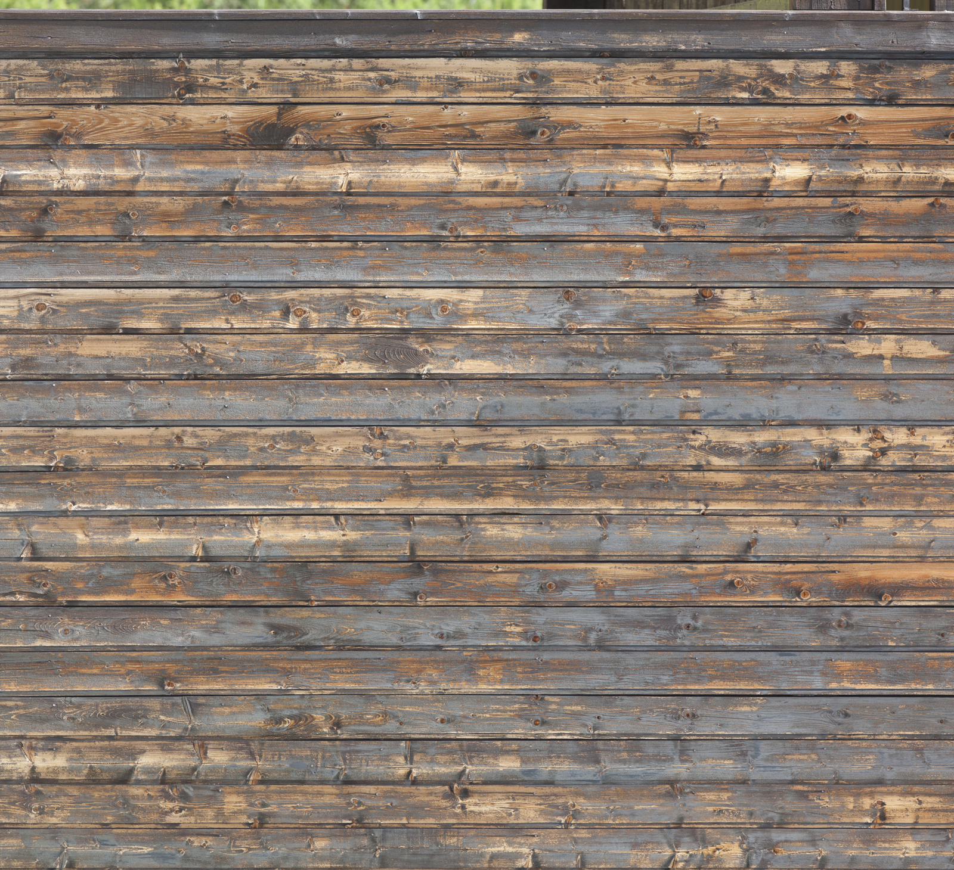

**All Assets Used:**

Wood Floors - http://www.textures.com/download/woodplankspainted0191/66695

Rusted Walls - http://www.textures.com/download/rustpaint0170/31195

Water Pit - http://www.textures.com/download/waterplain0035/103458